imi business & enterprise competition
Sponsored by Sytner

A UK wide competition for Schools and Colleges to take part in teams of 6 to design, brand and launch their very own vehicle.

The automotive industry influences everyone, from delivering goods on time to commuters travelling to work and emergency services being able to respond to crisis. The motor industry helps to keep the country moving.

The competition will focus and improve student’s skills such as teamwork, Communication, Leadership, Employability and Life Skills. Roles within the teams include Project manager, Marketing, Researcher, Administration, ICT coordinator and Presenter.

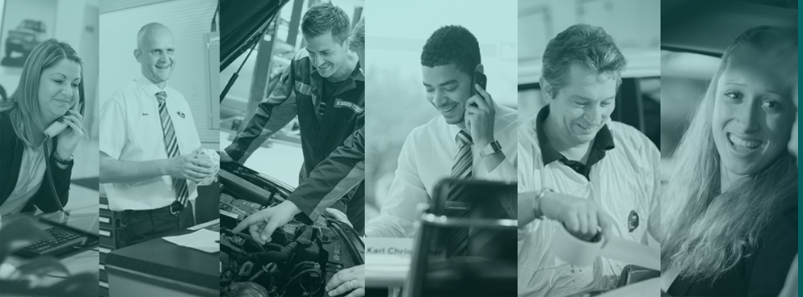

The Competition
Develop an outline of a logo, brand name and strapline for the business you are representing. We need to see clearly what your brand stands for and how you show this is entirely up to you. This competition aims for you to spend most of your time developing the launch of your vehicle and creating the entry to show how this will work. You could use video, social media, web design, PowerPoint, augmented reality or even virtual reality! In all areas of the entries we are looking for creativity.

The Brief
Decide who the target market you want to develop your new car is for. Consider the type of vehicle (sports car, family saloon, 4x4 etc), the name and key product features that will be attractive to your chosen target audience. Design your vehicle. Plan a proposal for the launch for your new vehicle. You need to use modern technology and creative ideas to promote your vehicle to your target audience through this launch and attract media attention. Your launch could be done or shown through a website, an App or a social media campaign that you have created, a video you have filmed or any other electronic medium that you would like to use.

Competition tasks
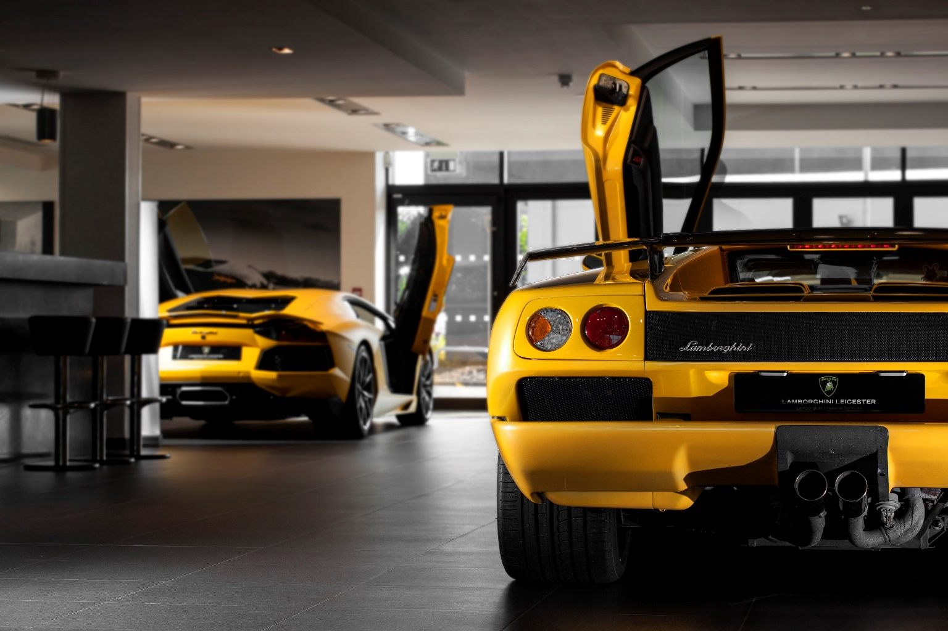
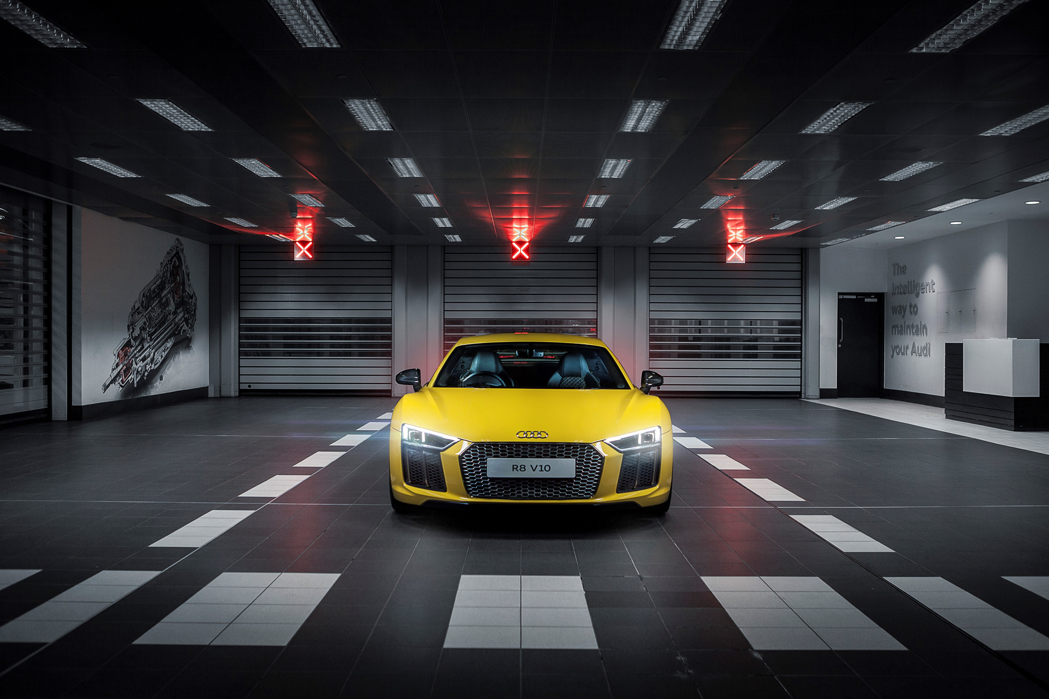
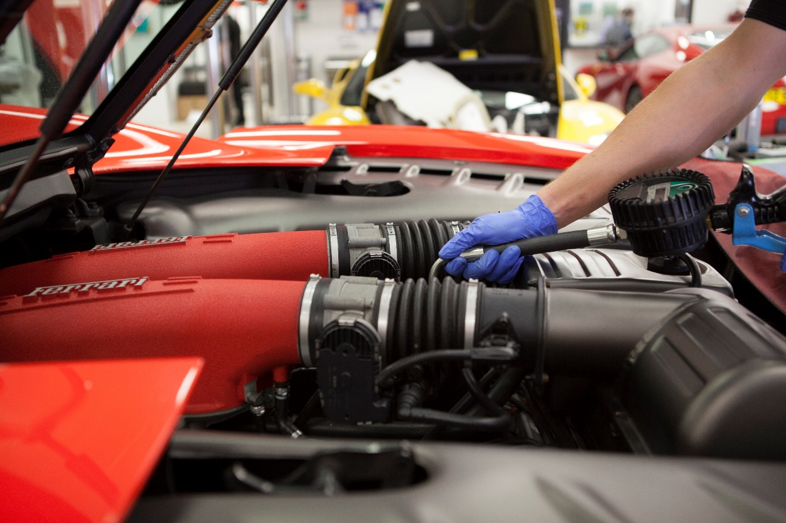
Research
- Choose a target market
- Explain why you chose them
- Explore what they would want from a new vehicle
Design
- Design and draw a vehicle for that target market including a unique selling point or gadget
- Explain why the vehicle and unique selling point /gadget would fit that target market
- Design and draw a brand name, logo and strap line for the vehicle
Strategy & Planning
- Explore how you are going to launch your vehicle
- Plan a media campaign to sell your vehicle (think about your target market and how they will hear about the new vehicle)
- Plan a launch event for your vehicle
- Plan an advert for your vehicle
- Present/pitch all of your ideas in a marketing presentation / PowerPoint / video

The prize
The winning team plus their teacher will be treated to a dream day out at Mercedes-Benz world located near Heathrow. Starting the day off with a fabulous breakfast in the AMG conference suite overlooking the track you will have a talk from the IMI and Sytner on careers in the industry before your VIP guided tour of the museum with special access to all of the attractions and exhibits. Not only that but you will also have your very own driving experience on the on or off road track depending on your age. There may also be some souvenirs heading your way as well!

Competition Guidelines
- Maximum of 6 students per team
- There are 2 available categories: School (13 – 16yr olds) or College (16 – 19yr olds) please state which one in your entry
- All entries are to be submitted electronically
- Areas to be covered – Brand, product, target audience and promotional activities
- Entries must be submitted by 31st May 2017 to careers@theimi.org.uk
- More information can be found on www.theimi.org.uk/autocity

Contact us
If you have any questions, queries or feedback please contact the Careers Team on careers@theimi.org.uk

About the IMI
The Institute of The Motor Industry is the professional body for individuals working in the motor industry and is the authoritative voice of the retail automotive sector. The IMI’s aim is to ensure that the automotive retail sector has a skilled, competent and professional workforce that is fully equipped to keep pace with the demands of new technology and changing markets. A key part of business for manufacturers and dealers is to encourage the best and brightest people to join their business in a variety of roles.

About Sytner Group Trainee and Apprentice Programmes
Sytner Group represents 20 of the world's most desirable car manufacturers in over 100 dealerships across the UK. Last year we sold over 135,000 cars and we serviced a further 230,000 Cars.

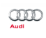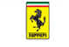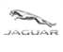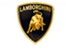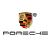

Founded by British Touring Car Champion Frank Sytner and his brother Alan in 1968, Sytner Group celebrates a one team spirit and strives to follow Frank's uncompromising driving style by offering an uncompromised customer experience. In 2002 Sytner joined the Penske Motor Group who shared the Sytner passion for motorsport. CEO, Roger Penske, being the founder of Penske Racing, the most famous race team on a worldwide basis, featuring in the NASCAR and Indy Racing series as well as Formula 1 in the 1970’s.
Sytner recognise that unparalleled customer service can only be achieved by attracting, motivating and retaining the very best team members. With this in mind, Sytner put their employees at the heart of everything we do and are proud to have achieved second place in the ‘Sunday Times Best Big Companies to Work For’ for the 2nd year in a row. They have been in the top 5 for the last 7 years.
Sytner Group are committed to developing talent and building careers, we work in partnership with the biggest car manufacturers in the world, leading training providers and industry specialists to offer comprehensive ‘on the job’ apprentice and trainee programmes. This offers the future Sytner stars a progressive and consistently successful investment in their career and personal development.
We welcome Apprentices and Trainees in to a wide range of business areas to kick start your career, these areas include:
- Technicians
- Sales Executives
- Service Advisors
- Parts Advisors
- Administration
Due to success and demand for the Sytner Group apprentice and trainee programmes we look to support the most proactive students who are prepared to go that extra and most innovative mile to secure themselves a fantastic career opportunity.
To find out more about our Apprenticeship and trainee Programme: https://careers.sytner.co.uk/

