IMI Business and Enterprise Competition Planner
Sponsored by Sytner

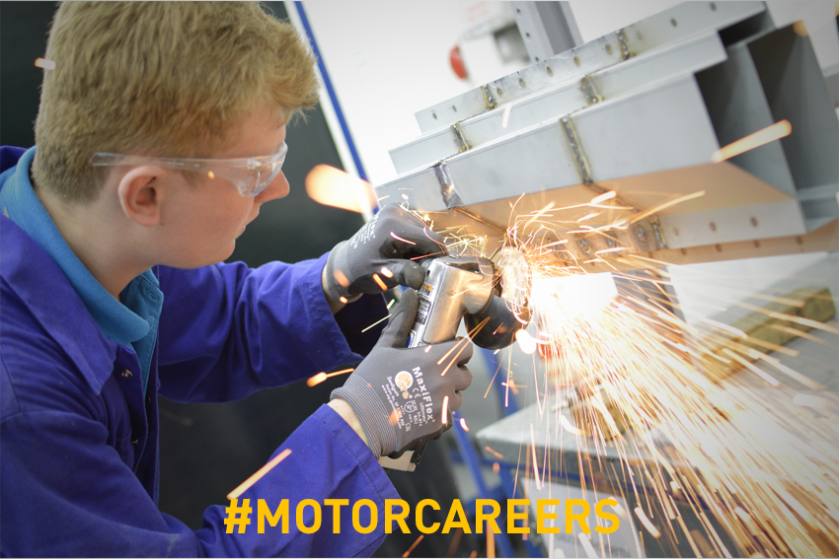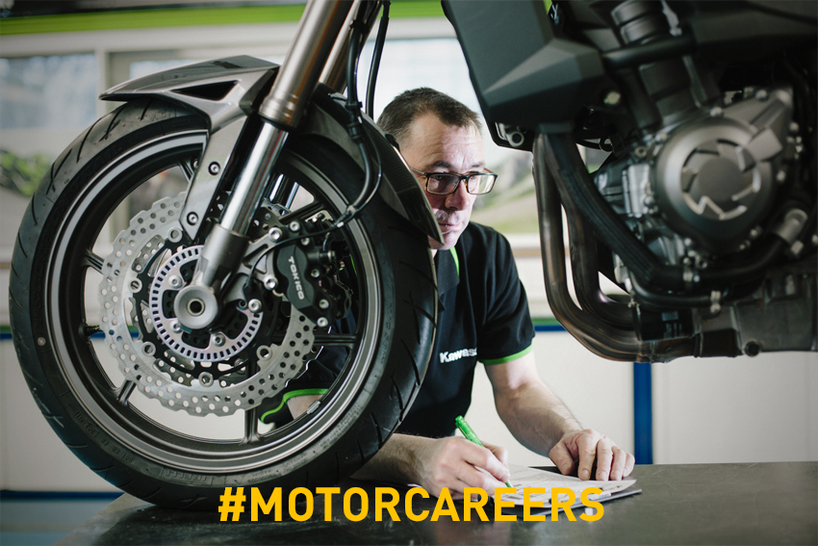

Team name:

Team participants: | 1  2  3  4  5  6
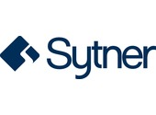

Your brief

You have been asked to design, brand and market a new vehicle for a specific audience. In teams of 6 you will need to:

Research
- Choose a target market from the list
- Explain why you chose them
- Explore what that audience would want

Design
- Design and draw a vehicle for that target market including a unique selling point or gadget
- Explain why the vehicle and unique selling point /gadget would fit that target market
- Design and draw a brand name, logo and strap line for the vehicle

Strategy
- Explore how you are going to launch your vehicle
- Plan a media campaign to sell your vehicle (think about your target market)
- Plan a launch event for your vehicle
- Plan an advert for your vehicle
- Present /pitch all of your ideas in a marketing presentation or PowerPoint

Finally send in a copy of your presentation or pitch to careers@theimi.org.uk for it to be marked by judges in the industry and you and your team may win the top prize of a special day out at Mercedes Benz World including an on track experience from the competition sponsors Sytner!

Use the following pages to help you plan out your project

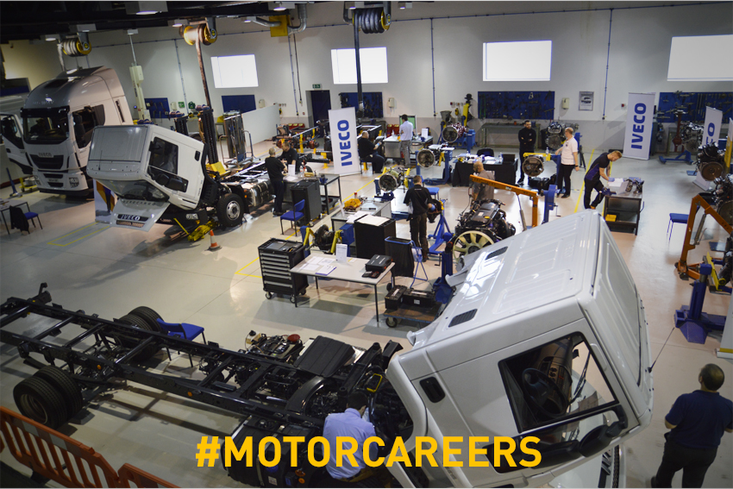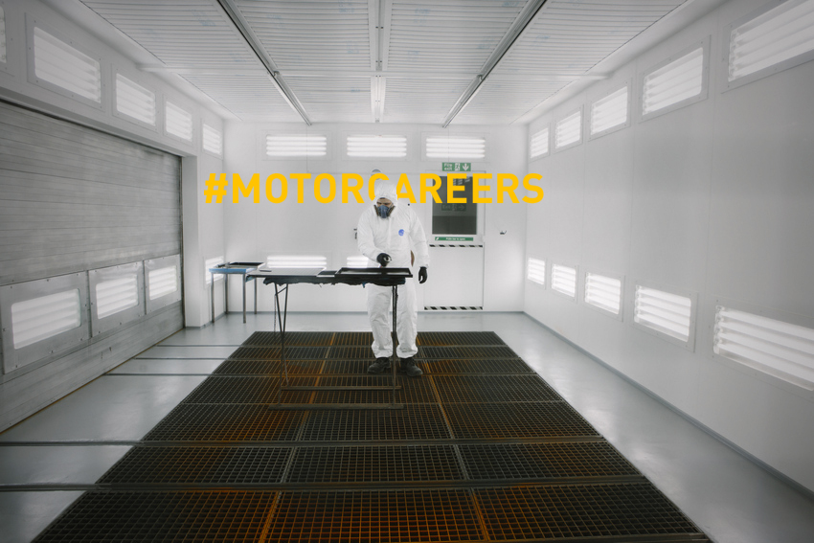

Research

Task one is to:
- Decide on your target market you will design your vehicle for.

Target markets

In your group decide which target market you are going to design, brand and launch your vehicle to from the list below, or you can describe your own target audience.

Choose a target market and then research their preferences, lifestyles, hobbies and finances etc. Write a description of the target market you are looking to design your vehicle for below. Include what your target market would be looking for in a new vehicle and what would appeal to them.
University graduate….

Single young professional….

Family of 5…

Middle-aged professional living in the city….

Retired couple living in the countryside….

A target market of your choice…

We chose this audience because….

Options

Research the types of vehicles already available to that audience.
- What are the good bits?
- What could be improved?
- What parts of the vehicle would appeal and are unique to that audience?
- What do the logo’s and strap lines look like?
- Why would all of these thig appeal to that audience?
Research findings….

What would your target audience WANT in a vehicle?

Now it’s time to start designing your vehicle for your chosen audience!
Design

Task two is to:
- Create a brand name, logo and strapline for your vehicle to match your target market and ensure you clearly define what your brand stands for

Brand your vehicle

What would you like your vehicle to be called?

Design your Logo

Draw some images of a logo you could use and decide on the one you like best.

Logo example….

Create your strap line

Now you need to think of a strapline for your car and the image you would like to portray. Can you guess where these ones are from?
- ‘Every little helps’
- ‘Because you’re worth it’
- ‘Just do it’

Now it’s time to come up with a Strapline for your new car. Jot down some words you like and try and piece them together.

Strapline ideas…

Final strapline…

Design your vehicle

What types of cars do you like that already exist today? (Think of a few different types)

Now, think of all the best bits from each vehicle. Try and come up with a new vehicle. Please draw a picture of your new vehicle.

Ideas…
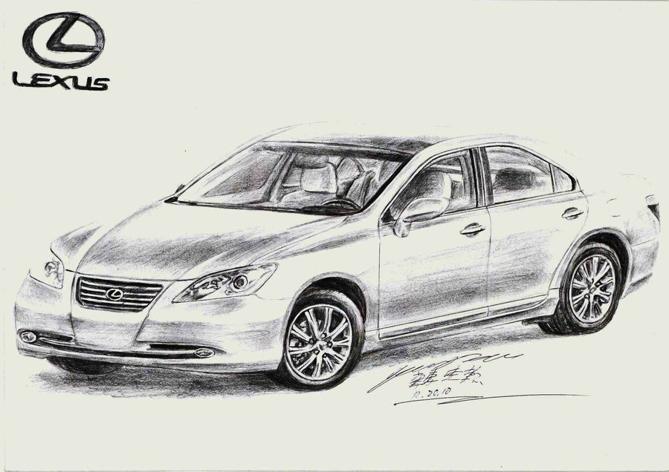

Design your unique selling point, gadget or app

Now that you know what your car looks like you need to come up with a ‘unique selling point’ that will appeal to your target market. Use your research on the target audience to help you design a unique gadget or app for your vehicle.

Here are some gadget ideas (that actually already exist) to inspire you:

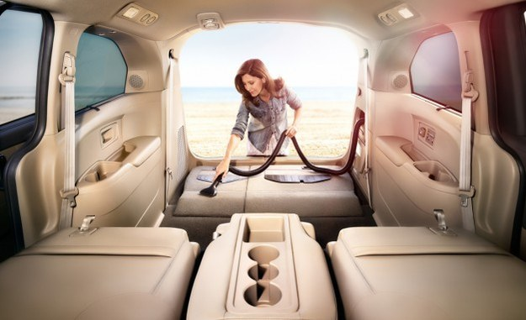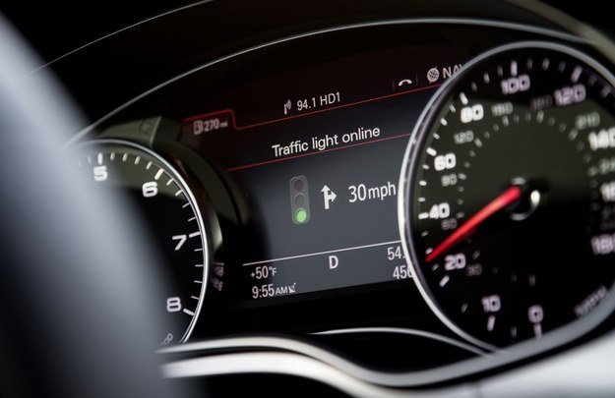

- A built-in vacuum for spontaneous spills and cleaning spells.
- Sensors that learn you’re driving style and can detect when you’re too tired to drive.
- A sunroof that automatically blocks light and lets you see what you want to.
- GPS that automatically analyzes traffic and finds the best way around it.
- Cars that recognize traffic light changes and count down until the next green light.
- Brakes and cameras that automatically keep you in the center of the lane.
- NASA-approved car seats that prevent fatigue on long drives.
- Windows that clean themselves and deflect liquid automatically.
- Heated wiper blades that melt ice and snow to keep everything clear.

What new and exciting features would you like your car to have?
Your USP ideas….

Now you have designed your vehicle it’s time to start planning the launch!
Strategy & Planning

Task 3
Now that you have decided on what your vehicle will look like, who your target audience are you need to decide how you will promote your vehicle. If you don’t promote your vehicle then no one will know you have created it.

Task three is to devise a promotional plan for your car and create a promotion that will appeal to your target audience by:
- Explore how you are going to launch your vehicle
- Plan a media campaign to sell your vehicle (think about your target market)
- Plan a launch event for your vehicle
- Plan an advert for your vehicle
- Present /pitch all of your ideas in a marketing presentation or PowerPoint

Explore some options for launching a new vehicle
E.g. At a large car event, special event at HQ, online?

Plan a media campaign to sell your vehicle (remember who your target market is and how they will hear about the vehicle). Wrote pit the steps you will take to promote your new vehicle.

Ideas….

How will you launch your new vehicle to the market?

What is the big promotion event you have planned?

How will you advertise your new vehicle?

Ideas….

Will you have a famous spokesperson, song or location for your launch?

Congratulations you have successfully researched, designed and planned how to market your vehicle! Only one last task remains….the pitch!

The pitch

Now it’s time to get all your ideas and plans together and create a presentation on your new vehicle. Remember to include:
- who the vehicle is for, what they would like and why you chose that audience,
- the logo, strapline and brand name of your vehicle, its design and the USP
- your big launch and marketing plan

You can either:
- Present or ‘pitch’ your ideas and film it
OR
- Create a PowerPoint presentation of all your ideas.

THEN: Make sure you spend in your entries to careers@theimi.org.uk for your chance to win!

